Barry C. Levin  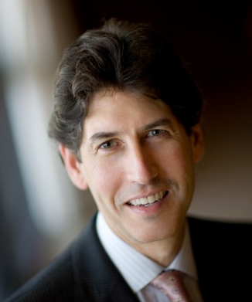  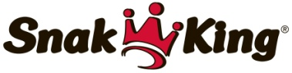  16150 East Stephens St.  City of Industry, CA 91745  (626) 363-7777  bclevin@snakking.com | Barry Levin is Chairman and CEO of Snak King Corp, one of the largest snack food manufacturers in the United States. In 1979, at age 21, Barry accepted an offer to manage a one year old, financially challenged pork rind manufacturing plant for absentee owners. Within the first year, Barry and his two fellow employees were able to make the company profitable. Shortly thereafter Barry had the opportunity to buy into the company, and over the following five years he purchased the balance of the stock.  Snak King began by producing a single item out of a 1,200 square foot facility and now manufactures over 950 sku's in California and Illinois and occupies more than 600,000 square feet. Once a three person operation, Snak King currently has over 1100 associates. Today the company private-labels and co-packs products for some of the largest retailers and food companies in the world. In addition, Snak King markets product nationally and internationally under its own brands which include The Whole Earth, El Sabroso, Jensen's Orchard, Snak King, Granny Goose and Vitner’s.  Barry's business plan has always been to pursue niche markets and to set industry trends. Kosher, organic, ethnic and specialty-flavored snacks comprise a large part of the Snak King product line. In addition to pork rinds the company manufactures tortilla chips, potato chips, popcorn, caramel corn, cheese puffs, cheese curls, veggie chips, roasted nuts, coated nuts, and trail mixes, nut cubes, nutritional bars and kettle corn. Guacachips, Salsitas, and Taco-Litos are just a few examples of products that have received national recognition.
 | Education
University of the Pacific, Stockton, CA
- B.S., Business Administration 1979
 | Personal
Married, 2 children
Hobbies: skiing, water skiing, triathlons, road and mountain biking, travel, photography

Professional Associations
Young President’s Organization (YPO) 1991-present
Snack Food Association Western Regional President 1992
E&Y Entrepreneur of the Year Finalist 1994
Chairman International Snack Food Association 2001-2002
E&Y Entrepreneur of the Year Finalist 2003
L.A. Chamber of Commerce Board of Directors 2006-2015
Chairman Executive Leadership Conference SFA 2006
Snack Food Manufacturer of the Year 2006
L.A. Business Journal Award of Excellence – Mfg 2006
E&Y Entrepreneur of the Year – Greater Los Angeles 2007
Snack Food Executive Team of the Year 2008
SBA Small Business Person of the Year – California 2011
White House Champion of Change 2011

