Theodore L. Adams
L Brands, Inc.
12 Pickett Place, New Albany, OH 43054
Peyton5085@aol.com * LinkedIn-Ted Adams

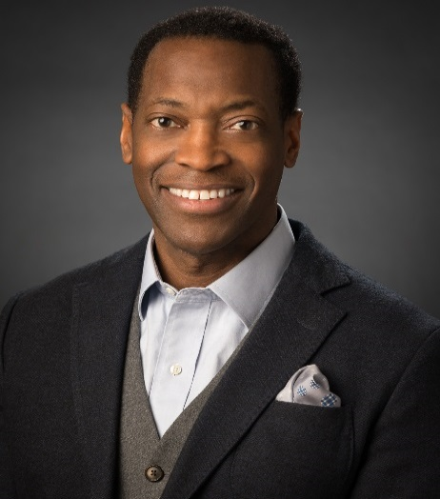
Ted has served as Vice President & Sr. Counsel for Company Affairs and Corporate Responsibility at L Brands for nearly two decades. In this role, Ted provides strategic advice to the company and its owner and founder Les Wexner.

Created in 1963, L Brands is the largest Owner-Founder led lingerie, beauty, and home fragrance company in America. L Brands, through Victoria’s Secret, PINK and Bath & Body Works, operates 2,943 company-owned specialty stores in the United States, Canada, the United Kingdom and Greater China, and its brands are also sold in more than 650 franchised locations worldwide.

As a corporate strategist and guardian of Brand reputation, Ted has a proven track record of performance in all facets of corporate relations (external affairs, communications, marketing and government affairs) and legal affairs (brand protection, international trade). Ted co-developed a sustainable organic cotton program for Victoria’s Secret, designed a framework to protect L Brands’ intellectual property interests in overseas markets, implemented a strategy for proactive compliance with FCPA guidelines, and co-led an economic development project for L Brands’ beauty and personal care manufacturing campus in Ohio.

Prior to his role at L Brands, Ted served as a Senior Advisor to the Ohio Attorney General. In this capacity, he advised the Attorney General on a broad range of policy matters while overseeing all litigation assigned to private counsel on behalf of the State of Ohio. Ted co-managed the State’s plan to liquidate Ohio’s largest private medical insurance company, retained counsel to pursue recovery of Ohio’s pension funds losses in the Enron crisis, and co-directed two of the largest consumer protection cases in Ohio’s history (the Firestone Tires and Anti-tobacco/smoking campaigns).

As a Special Assistant United States Attorney and co-leader of the Financial Crimes Unit, Ted pursued recovery of assets in one of the largest tax fraud cases in the Southern District of Ohio. He prosecuted health care fraud, asset forfeiture, and crimes committed on federal lands – Wayne National Forrest. As a deputy counsel to the Governor of Ohio, Ted had oversight responsibility for all litigation involving the Governor and Ohio’s cabinet agencies. He helped to implement the State’s crisis plan for the largest prison riot in Ohio history and in the aftermath of the State’s first public sector workplace shooting.

Ted is a recognized leader in the community. He represents L Brands and its Founder as an ambassador for civic and philanthropic endeavors and has served as a trustee for numerous civic and non-profit organizations over the last 25 years. In this capacity, Ted helped secure significant public financial support for the construction of the James Cancer & Solove Research Hospital at The Ohio State University and federal funding for Graduate Medical Education program at Nationwide Children's Hospital.
Ted earned his bachelor’s degree in Political Science from Wittenberg University, a law degree from The Ohio State University Moritz College of Law, and a Master’s Degree in Sports Management from The Ohio State University School of Human Ecology and Education.

Board Experience

Nationwide Children's Hospital - compensation and diversity committees
• Construction of world class clinical and research center, preservation of NIH funding (i.e. GME)

The Ohio State University Stress, Trauma and Resilience Program (‘STAR’) - Trustee
• Best in class behavioral health program to address stress and trauma among medical caregivers.

The Ohio State University Alumni Advocates
• University President’s Advisory Council for Public Policy.

Jobs Ohio Beverage – Trustees appointed by the Governor of Ohio
• Oversight and governing body for the Spirits industry in Ohio
• Proceeds fund economic development projects throughout the State of Ohio.

The ‘Straight A Fund’ – Trustee appointment by the Governor of Ohio
• Ohio’s Innovation Fund for Primary/Secondary Education initiatives.

‘33rd Republic’ – Board advisor to an online children’s apparel retail startup

Ohio Council of Retail Merchants - Vice Chairman
• Statewide advocacy organization for merchants and retailers based in Ohio.

United States Senate Commission for Judicial Vacancies (2016, 2017, 2018) – U.S. Senate Appointment
• Selection Committee for Federal District Court Judges in Ohio.

Prevent Blindness Ohio - strategic planning, budget and finance committees
• Ohio’s public health advocate for vision care.

Make a Wish Foundation for Ohio Kentucky and Indiana - Board chairman
• Wish granting organization for children challenged with life threatening medical conditions.

Mount Carmel Health Foundation (Trinity Health) – Development committee chair
• Patient care and outreach for one of largest healthcare providers in the U.S.

The Ohio Attorney General’s Office: Legal counsel to Ohio’s public boards and commissions:
- Public two and four year colleges and universities.
- The Ohio Board of Regents.
- The Ohio Tuition Trust Authority (Ohio’s 529 plan).
- Ohio’s five (5) public pension funds.
State Teachers Retirement, Public Employees Retirement, State Highway Patrol Officers, School Employees Retirement, and Ohio Police & Fire.

New Albany Community Authority – Trustee
• Tax and Finance Authority for economic development.

Columbus Legal Aid Society - strategic planning, finance and program committees
• Provides legal services for underserved communities in central Ohio.

