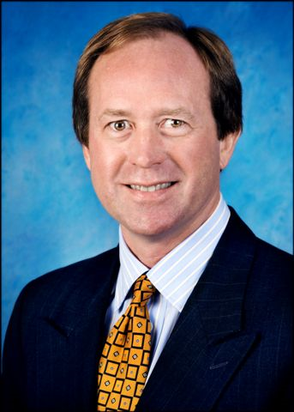

James C. Collet

James Collet is Chief Executive Officer of Sheridan Industries, Inc. an operationally oriented private equity firm focused on making direct investments in profitable businesses with a solid track record of performance, a sustainable franchise and unique growth opportunities. Prior to his formation of Sheridan, Mr. Collet was Managing Director and Co-Chief Investment officer for HFI, the family office for the Kenneth A. Hersh family as well as its affiliates including NLM Capital Partners, II.

Prior to his direct investing experience, Mr. Collet was Chief Executive Officer of a number of institutional backed manufacturing and industrial service companies in a variety of industries including energy services, metal fabrication, plastic injection molding and store fixture and point of purchase display. From 1998 to 2001, he served as a Division President for the Store Fixtures Division of Leggett & Platt (NYSE: LEGG) where he successfully consolidated 7 companies in the store fixture, storage products and point of purchase display sectors with annual revenues in excess of $350 million. Prior to his principal investing experience, Mr. Collet spent 10 years in the investment banking business holding senior positions with Samco Capital Markets and Ernst & Young LLP

Mr. Collet currently Executive Chairman of ASD Therapy Solutions, LLC, serves on the Board of Directors of ARP AIS, LP, Alliance Tank Services, is the Chairman of the Advisory Board for Green Square Capital, LLC and serves as a senior Board advisor to RK Supply. Mr. Collet is also a Senior Advisor to several operationally focused private equity firms including Clavis Capital Partners, Core Industrial Partners and Havencrest Healthcare Partners. Mr. Collet is an active member of the Young Presidents Organization and served on the International Board of Directors from 2007-2010 and on the International Board for the World Presidents Organization from 2014-2016. Mr. Collet holds BBA and MBA degrees, with distinction, from Southern Methodist University in Dallas, Texas.

